Tarrant County Probate Court l 00 W. Weatherford
Fort Worth, Texas76196
Patricia M. Burns, Judge Probate Court Number One
S. Brook Bell, Judge Probate Court Number Two

February 10, 2026

SMALL ESTATE AFFIDAVITS AND THEf f i USE

Attached are instructions which have been prepared for your use in completing the Small Estate Affidavit.
Small Estate Affidavits allow family members to collect the assets ofan estate where there is no will and no need to have a person appointed to handle the business ofthe estate. To use a Small Estate Affidavit, the assets ofthe Estate, not counting the homestead and property classified as exempt by the property code, cannot be more than $75,000.00. Debts ofthe estate must not exceed the non-exempt assets.
It is AGAINST THE LAW for any Tarrant County employee to give you advice or answer qu estions on the use of this form. Please do not ask them to break the law.
Instructions are attached for youruse, along with telephone number where legal advice is available.

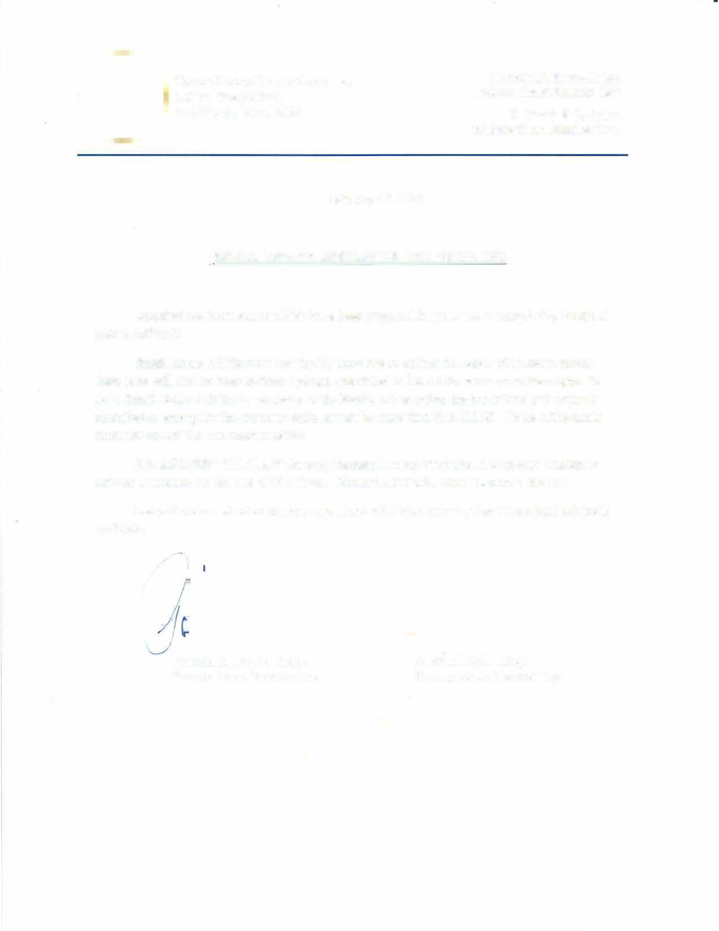

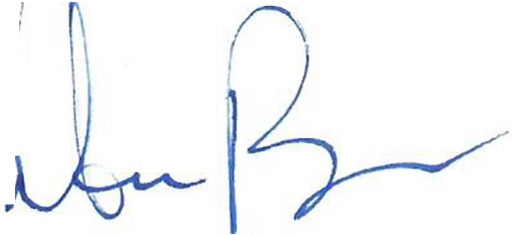
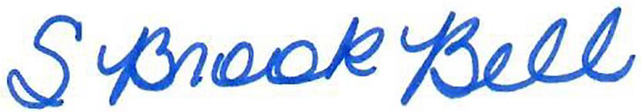
Patricia M. Burns, Judge Probate Court Number One
S. Brook Bell, Judge Probate Court Number Two

.•·······.····.•
.·••.•_-.",.,col, ',l'J.�"••··
ff
,er\ Tarrant County. Probate Cow1
�;:_ t 100 W. Weatherford
... .. ...
\ / Fort Worth, Texas 76196
·• •·
•••···•••

Patricia M. Burns, Judge Probate Court Number One
S. Brook Bell, Judge Probate Court Number Two

SMALL ESTATE AFFIDAVIT

- FILING Fee: $404.00
(Includes 1 Certified Copy and Poster Citation)

- Please make checks payable to:

Mary Louise Nicholson, County Clerk Tarrant County Courthouse
100 W. Weatherford Street, Room B-90 Fort Worth, Texas 76196-0401

········;·•··
f:-_a·�, u.vt,;t\ Tarrant County Probate Cou1t
\_;; . . �_..} I 00 W.Weatherford
..
.. ..
Fort Worth, Texas 76196
S. Brook Bell, Judge
Probate Court Number Two

Patricia M. Burns, Judge Probate Court Number One

··• ..: .. ! .. : .. -··

INSTRUCTIONS FOR USE OF THE SMALL ESTATE AFFIDAVIT AUTHORIZED BY TEXAS ESTATES CODE CHAPTER 205

WHO CAN USE THE AFFIDAVIT?

The small estate affidavit can be u ed only if ALL of the following conditions apply:

I. The deceased person died WITHOUT a will. lfthere is a will, a small estate affidavit CANNOT be used whether the will has been offered for probate or not.
- More than thi1ty (30) days must have passed since the date of death.
- The only real property O\\ ned by the Decedent must be the homestead. Title to other real prope1ty is unaffected by the small e tate affidavit. A small e tate affida it cannot be used to transfer title to any other real prope1ty other than the home tead. Homestead is that which is retained by surviving spouse and/or minor child ONLY.
- The debts of the Decedent (other than a mortgage on the homestead) mu t not exceed the assets of the Decedent (not counting homestead and exempt prope1ty) and there must be no other reason to have a person appointed to handle the business of the Decedent' e tate.
- No estate administration has been opened or if an application to open one has been filed. no order has yet been entered granting letters of administration.
- The Decedent must have had a permanent place of residence in this county at the time ofhi or her death.
- All of the asset of the Decedent (not counting homestead and exempt property) are not more than
$75,000.00. on the date of the affidavit.
- It cannot be used to exclude any heir.
- It cannot be used if any of the heir are under the age of 18 or incapacitated.
HOW TO COMPLETE THE AFFIDAVIT?

I. You MUST answer ALL questions. If a question doesn't apply mark with NIA.
- The affidavit must be completed by persons" ith actual knowledge of the facts stated and signed by ALL distributes (heirs).
- Also, two persons who have personal knowledge of the family history fact and who have no financial interest in the Decedent's estate ("disinterested persons") mu t sign and swear to the affidavit.
- All persons who sign the affidavit (whether heirs or disinterested persons) must personally appear before a otary Public and swear to the contents of the affidavit.
- Asset and liabilities must be identified and described and all values must clearly be set out with all as ets de ignated as separate or community property.
- All a sets must be liste,d ith a physical address of where the a set is located and with the current
market value as of the date of the Decedent's death.
- The heirship of the Decedent mu t be set out, with the names and addre ses of all heirs shown. their relationship to the Decedent and the share each heir will take shO\ n. (A chart explaining heirship division i attached to thi sheet. Please see Exhibit A.)

- All marriages, divorces or deaths of spouses and births and deaths ofchildren must be listed.

  - If any children or descendants of the Decedent are NOT also children and descendants of the surviving spouse. this fact must be shown.
  - If any other person survived the Decedent other than children, such a parents, grandparents. brothers and sisters. half-brothers and half-sisters, or other people, this fact must be shown.
  - o one is the heir ofa living person. so that. ifa child of the Decedent, ould inherit a share. that child's children would not inherit fom the Decedent.

EFFECT OF THE ORDER?

The order approving the mall e tate affidavit does not order any property transferred, but only find that the affida it:
I. complie with the pro isions of the Texa Estates Code,
- has been filed in the proper court.
- the estate qualities as a "small e tate" under the E tates Code,
- the affidavit hould be appro ed. and
- directs the Probate Clerk to record the affidavit and issue copies to all person entitled to them.

IT IS ILLEGAL FOR ANY COUNTY EMPLOYEE TO GIVE YOU ANY ADVICE ON THE USE OF THIS FORM.

If you have legal questions, you might call:
  - Tati-ant County Bar Association Lawyer Referral Service - 817.336.410 I
Tarrant County Bar Association "Legal Line" (2nd & 4th Thursday 6-8pm)- 817.335.1239
  - West Texa Legal Services ("Legal Aid")- 817.336.3943

Exhibit A
SECTION 11 (E) DISTRIBUTEES PURSUANT TO STATUTE
These determinations are made based on events at the time of the deceased's death.

- With surviving spouse and all children are those of surviving spouse.
  - Separate personal property
    - Spouse 1/3 share
    - Children equally take 2/3 share
  - Separate real property
    - Spouse life estate in 1/3
    - Children equally take 2/3 in fee and plus 1/3 remainder interest subject to spouses life interest
  - Community property
    - Spouse 100%
    - Children taken none
- With surviving spouse and at least one child from another relationship
  - Separate personal property
    - Spouse 1/3 share
    - Children equally take 2/3 share
  - Separate real property
    - Spouse life estate in 1/3
    - Children equally take 2/3 in fee and plus 1/3 remainder interest subject to spouses life interest
  - Community property
    - Spouse 0% of Decedent's share
    - Children equally share 100%
- With surviving spouse and no living children
  - Separate personal property
    - Spouse 100%
  - Separate real property
    - Spouse takes 1/2
    - Equally to parents (if one is deceased then their share to siblings equally, and if one sibling is deceased then the deceased sibling share to their children) If no descendants of parents then all to spouse.
  - Community property
    - Spouse 100%
- No surviving spouse, but with living children
  - All Property: Children share 100% equally (if child is deceased then their share to that deceased child's children)
- No surviving spouse and no living children but parents living
  - All Property: Equally to parents (if one is deceased then their share to siblings equally, and if one sibling is deceased then the deceased sibling share to their children)
- No surviving spouse, no ling children, no living parents.
  - All Property equally to siblings (deceased sibling share to the deceased sibling's children)
- No surviving spouse, no living children, no living parents and no living siblings.
  - All Property: Equally to nieces and nephews (deceased niece/nephew share goes to that deceased niece/nephew's children)

NO.

ESTATE OF

DECEASED
§ IN PROBATE COURT
§
§ NUMBER OF
§
§ TARRANT COUNTY, TEXAS

SMALL ESTATE AFFIDAVIT

On the day or days below written, personally appeared the distributees of this Estate and two disinterested witnesses, who, on their oaths, did swear or affirm to the following facts pursuant to Chapter 205, Texas Estates Code:
- Decedent died on m

County, valid Last Will and Testament;
without leaving a

- A redacted copy of Decedent's death certificate will be filed in this cause number at the time this Affidavit is filed;

- Decedent was a resident of and domiciled in County, Texas at the time of Decedent's death;

- No administration is pending or has been granted in Decedent's estate and none appears necessary;
- More than thirty (30) days have elapsed since the death of Decedent;

- The value of the entire assets of the estate of Decedent as of the date of this affidavit, exclusive of homestead and exempt property, does not exceed $75,000.00;

- The value of the entire assets of the estate of Decedent as of the date of this affidavit, exclusive of homestead and exempt property, exceed the known liabilities;

- Medicaid:
Claims for Medicaid recovery in Texas are debts of the estate. If the Decedent did not apply for and receive Medicaid benefits on or after March 1, 2005, check the box below:

D The Decedent did not apply for and receive Medicaid benefits on or after March 1, 2005.

If the decedent did apply for and receive Medicaid benefits on or after March 1, 2005, then the Medicaid Estate Recovery Program ("MERP") may have a claim against the estate. A certification must be obtained from the Health and Human Services Commission (formerly the Texas Department of Aging and Disability Services) and attached to the affidavit. The required form is available at: http://www.dads.state.tx.us/services/estate recovery/ TXMERPCertificationForm. pdO.

Based on the certification, the following statement applies:

  - The Texas Department of Health and Human Services has certified that no claim is pending and the state does not intend to file a claim.
  - The Texas Department of Aging and Disability Services has withdrawn or waived any claim
against the Decedent's estate.
  - The Texas Department of Aging and Disability Services has a Medicaid Estate Recovery Program
(MERP) claim which is listed as a liability in paragraph 10 below.
- All of the assets of Decedent's estate and their value are as follows: (use additional pages as necessa,y)
**YOU MUST INCLUDE SOME ASSETS HERE.**

Description of Assets
Provide sufficient detail to identify property; including, name & last four digits of the account number; and address & legal description of real property.

SEPARATE PROPERTY:
Value
Market value as of the date of this affidavit.
Additional Information
Provide facts to explain why asset is Community or Separate Property.
Exempt assets must be identified
if Decedent was survived by spouse, minor children, or unmarried adult children who lived with Decedent.

Texas Family Code§ 3.001. SEPARATE PROPERTY. A spouse's separate property consists of: (1) the property owned or claimed by the spouse before marriage; (2) the property acquired by the spouse during marriage by gift, devise, or descent; and (3) the recovery for personal injuries sustained by the spouse during marriage, except any recovery for loss of earning capacity during marriage.

TOTAL
COMMUNITY PROPERTY:
Texas Family Code§ 3.002. COMMUNITY PROPERTY. Community property consists of the property, other than separate property, acquired by either spouse during marriage.
Texas Family Code§ 3.003. PRESUMPTION OF COMMUNITY PROPERTY. (a) Property possessed by either spouse during or on dissolution of marriage is presumed to be community property. (b) The degree of proof necessary to establish that property is separate property is clear and convincing evidence.

TOTAL

- All liabilities/debts of the Decedent's estate and their values are as follows:
The affidavit must list all of Decedent's debts and other liabilities including all credit card balances, doctor and hospital bills, utility bills, etc. - everything owed by Decedent or Decedent's estate and not paid off If none, write "none." If funeral debts or attorney's fees and expenses will be paid from estate assets, list them here.

Description of Debts Balance Due

TOTAL _
If attorney's fees were not listed above as a liability, but one or more distributees have paid or will pay attorney's fees for preparation and/or advice regarding this Small Estate Affidavit, indicate the amount of those fees here: $ _ Indicate who has paid or will pay the fees:

- The following facts regarding Decedent's family history show those who are entitled to the Decedent's assets and their respective shares; to the extent that, exclusive of homestead and exempt property, the Decedent's assets exceed the liabilities of Decedent's estate (complete all that apply).
  - Marriage:
On the date of Decedent's death, Decedent was:
D a single person, (01)
D married to ("Surviving Spouse") on (date).
  - Children:
D Decedent had no children by birth or adoption who survived the Decedent and Decedent did not take any children into Decedent's home, to raise as a child, who survived the Decedent. (01)
D The following children were born to or adopted by Decedent. List all children, whether or not the child is still alive and whether or not parental rights were later terminated. If parental rights were terminated for any child, give details on separate page(s).
Name of Child Date of Birth Name of Child's Other Parent

D All of the Decedent's children were alive when the Decedent died. (or)
D The following of Decedent's children died before the Decedent, and were survived by the following children (or grandchildren, etc.):

Name of Deceased Child Date of Death Name of Children of Deceased Child

D The following of Decedent's children died before the Decedent and were not survived by children (or grandchildren, etc.):
Name of Deceased Child Date of Death

If Decedent was survived by any children or their descendants, you do not need to answer "C. Parents" or "D. Siblings" below and may skip to "E. Chart of Distributees."

  - Parents:
    - Decedent was survived by both parents: and
� or
    - Decedent was survived by one parent: _,and
Decedent's other parent, ,died on
D Both of Decedent's parents pre-deceased the Decedent.

  - Siblings:
D Decedent was survived by the following brothers and sisters who were alive on the date of Decedent's death:
Name of Sibling Date of Birth Full or Half Sibling

D The following siblings pre-deceased the Decedent:
Name of Sibling Full or Half Sibling Children of Deceased Sibling & Birthday

D Decedent was survived by neither of his/her parents, brothers or sisters, nor nephews or nieces; but was survived by the individuals listed on the attached sheet showing the names and relationship to the Decedent, including date of birth and death, and Decedent's family history with respect to such survivors.

  - Chart of Distributees: Based on the family history given in this Affidavit, the following chart lists the name, address, telephone number, and e-mail address of each of the Decedent's heirs, together with their fractional interests in Decedent's estate:

Name/Address/Telephone/E-mail Relationship Share of Separate
Personal Property
Share of Separate Real Property
Share of Decedent's Community Prope1ty

DISTRIBUTEES:

We, the Distributees of this estate, as indicated by our signatures below:

- understand that this Affidavit and any court order approving the same do not serve to transfer title to any real estate owned by Decedent or affect the title to same, except that title to a homestead that is the only real property in a decedent's estate and which passes to a person in whose hands it is already homestead;
- understand that Texas Estate Code Section 205.007(c) provides that each person who executes this Affidavit is liable for any damage or loss to any person that arises from a payment, delivery, transfer, or issuance made in reliance on the Affidavit; and
- do solemnly swear or affirm that each of us have legal capacity and that the foregoing Affidavit was completed by persons who had actual knowledge of the facts stated herein and that this Affidavit is true, complete and correct, to the best of our knowledge.

STATE OF § COUNTY OF §

I am a Distributee of the Estate of ,Deceased. I swear or affirm that I have personal knowledge of the facts stated in the foregoing Affidavit and that the facts contained in the Affidavit are true and complete to the best of my knowledge.

Distributee's printed name Distributee's signature

SWORN TO AND SUBSCRIBED before me by Distributee, on
_,a

STATE OF §
COUNTY OF §
(Seal) Notary Public, State of _ Identification Number:

I am a Distributee of the Estate of � Deceased. I swear or affirm that I have personal knowledge of the facts stated in the foregoing Affidavit and that the facts contained in the Affidavit are true and complete to the best of my knowledge.

Distributee's printed name Distributee's signature

SWORN TO AND SUBSCRIBED before me by ,a Distributee, on

(Seal) Notary Public, State of _ Identification Number:

STATE OF § COUNTY OF §
I am a Distributee of the Estate of � Deceased. I swear or affirm that I have personal knowledge of the facts stated in the foregoing Affidavit and that the facts contained in the Affidavit are true and complete to the best of my knowledge.

Distributee's printed name Distributee's signature

SWORN TO AND SUBSCRIBED before me by ,a Distributee, on

(Seal) Notary Public, State of _ Identification Number:

STATE OF § COUNTY OF §
I am a Distributee of the Estate of ,Deceased. I swear or affirm that I have personal knowledge of the facts stated in the foregoing Affidavit and that the facts contained in the Affidavit are true and complete to the best of my knowledge.

Distributee's printed name Distributee's signature

SWORN TO AND SUBSCRIBED before me by ,a Distributee, on

(Seal) Notary Public, State of _ Identification Number:
STATE OF § COUNTY OF §

I am a Distributee of the Estate of � Deceased. I swear or affirm that I have personal knowledge of the facts stated in the foregoing Affidavit and that the facts contained in the Affidavit are true and complete to the best of my knowledge.

Distributee's printed name Distributee's signature

SWORN TO AND SUBSCRIBED before me by ,a Distributee, on

(Seal) Notary Public, State of _ Identification Number:

DISINTERESTED WITNESSES:

STATE OF § COUNTY OF §
I swear or affirm that: I have no interest in the estate of the Decedent herein; I am not related to the Decedent under the laws of descent and distribution of the State of Texas; I have personal knowledge of the facts stated in the foregoing Affidavit; and that the facts contained in the Affidavit regarding family history, assets, and liabilities are true and complete to the best of my knowledge.

I understand that Texas Estates Code Section 205.007(c) provides that each person who executes this Affidavit is liable for any damage or loss to any person that arises from a payment, delivery, transfer, or issuance made in reliance on the Affidavit.

Disinterested Witness's printed name Disinterested Witness's signature

SWORN TO AND SUBSCRIBED before me by � a disinterested witness, on

(Seal) Notary Public, State of _ Identification Number:

STATE OF § COUNTY OF §

I swear or affirm that: I have no interest in the estate of the Decedent herein; I am not related to the Decedent under the laws of descent and distribution of the State of Texas; I have personal knowledge of the facts stated in the foregoing Affidavit; and that the facts contained in the Affidavit regarding family history, assets, and liabilities are true and complete to the best of my knowledge.

I understand that Texas Estates Code Section 205.007(c) provides that each person who executes this Affidavit is liable for any damage or loss to any person that arises from a payment, delivery, transfer, or issuance made in reliance on the Affidavit.

Disinterested Witness's printed name Disinterested Witness's signature

SWORN TO AND SUBSCRIBED before me by ,a disinterested witness, on

(Seal) Notary Public, State of _ Identification Number:

NO.

ESTATE OF

DECEASED
§ IN PROBATE COURT
§
§ NUMBER OF
§
§ TARRANT COUNTY, TEXAS

ORDER APPROVING SMALL ESTATE AFFIDAVIT

On this day, the Court considered the above Small Estate Affidavit and the Court finds that:

l. this court has jurisdiction and venue;
- the Affidavit conforms to the terms and provisions of Texas Estates Code Chapter 205;
- based on the Affidavit, this Estate qualifies under the provisions of the Texas Estates Code as a Small Estate, pursuant to Texas Estates Code Section 205.001;
- the Distributees named in the Affidavit are entitled to receive the property of the Decedent set forth in the Affidavit only to the extent that the assets of the Estate (exclusive of homestead and exempt property) exceed the known liabilities of the Estate (exclusive of liabilities secured by homestead or exempt property); and
- the Affidavit should be approved.

Nothing in this Order:

- affects the disposition of property under a will or other testamentary instrument;
- transfers title to real estate, except as provided in Section 205.006 of the Texas Estates Code;
- transfers title to any property of the Decedent not listed in the Affidavit;
- deprives any creditor, whether disclosed or not, of any rights in any real or personal property transferred;
- deprives any heir, whether disclosed or not, of any ownership interest in any real or personal property transferred;
- establishes the separate or community nature of any property described in the Affidavit;
- constitutes a judicial determination of the legal heirs of the Decedent; or
- limits the personal liability of the Distributees and Disinterested Witnesses to any person (including but not limited to undisclosed heirs and any person having a prior right to property of the Estate) for any damage or loss arising from any payment, delivery, transfer or issuance made in reliance on the Affidavit.

It is therefore ORDERED, ADJUDGED and DECREED that the foregoing Affidavit be and the same is hereby APPROVED, and shall forthwith be recorded in the records of the County Clerk, and the Clerk of this Court shall issue certified copies thereof to all persons entitled thereto.

SIGNED

JUDGE PRESIDI G

