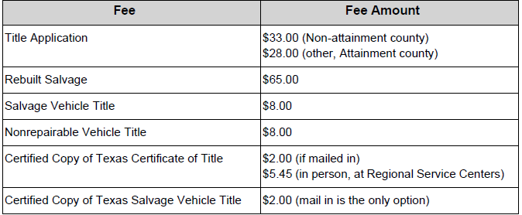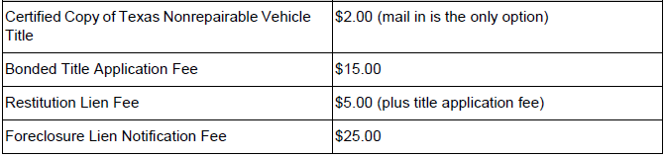

Source: Motor Vehicle Title Manual, Table 3-2, October 2014

